Mitosis/Meiosis and Genetic Diseases

All images have been acquired from:

http://www.emc.maricopa.edu/faculty/farabee/BIOBK/BioBookmeiosis.html

I. The Cell Cycle

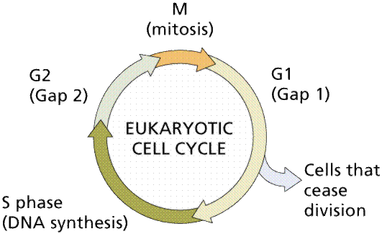

M (Mitosis) – consists of prophase, metaphase, anaphase, and telophase
G₁ (Gap 1) – ATP-dependent growth occurs; some cells may enter a G_{o} phase after G₁, where no further division occurs unless the cells are stimulated.
S (Synthesis) – After reaching a threshold size and ATP level, the cells replicate their original DNA molecules.
G₂ (Gap 2) – ATP that was depleted during synthesis is replenished for mitosis.
Collectively, G1/S/G2 is known as Interphase.

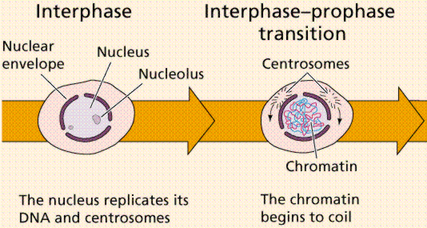

II. Mitosis

- The process of forming genetically identical daughter cells via replication and divison of the parent cell’s original chromosomes. Mitosis deals only with the segregation of the chromosomes and organelles into daughter cells. Cytokinesis is the actual physical division of the cell.

- Eukaryotic Chromosome Structure

Humans have a total of 46 chromosomes, which are condensed forms of chromatin (DNA + histone proteins). During mitosis/meiosis, the chromosomes replicate and are subsequently condensed.

Structurally, the chromosome has many important features. Replicated chromosomes consist of two molecules of DNA (along with their associated histone proteins) known as chromatids. The area where both chromatids are in contact with each other is known as the centromere; the kinetochores are on the outer sides of the centromere. During mitosis/meiosis, the microtubular spindle apparati attach to the kinetochores, located on the centromere.

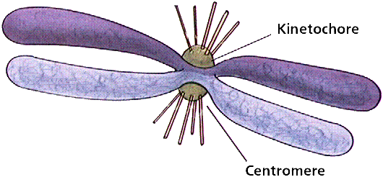
C. Stages of Mitosis

Mitosis consists of 4 stages: prophase, metaphase, anaphase, and telophase.

- Prophase is the first stage of mitosis; during prophase, the chromatin (replicated chromosomes) condenses, the nuclear envelope disintegrates, the nucleoli disappear, centrioles divide and begin to migrate to opposite poles of the cell, kinetochores and kinetochore fibers form, and the mitotic spindle forms.

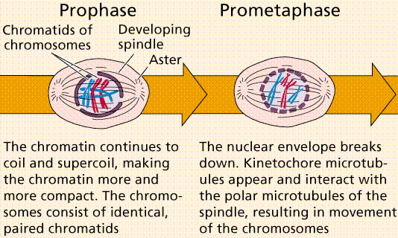

- Metaphase is the second stage of mitosis, characterized by the
migration of chromosomes (sister chromatids held together via a centromere) migrate to the metaphase plate, located in the center of the cell, along the spindle equator. Once the chromosomes have migrated, the spindles are attached to the chromosome kinetochore fibers.
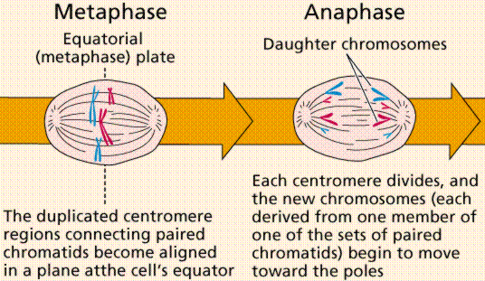

- Anaphase is the third stage of mitosis and begins with the separation of sister chromatids from the centromere and the pulling of chromosomes (now consisting of only one chromatid) to opposite ends of the spindle.

- During Telophase, the final stage of mitosis, the chromosomes reach opposite poles of the spindle, and a nuclear envelop begins to develop around each set of chromosomes. The chromosomes subsequently uncoil and the nucleolus reappears.

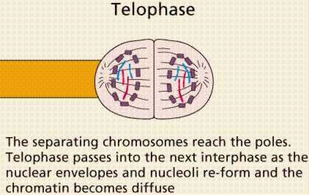

- Cytokinesis, while not a “true” stage of mitosis, occurs immediately after telophase as the cytoplasm is partitioned along a cleavage furrow and cellular organelles are allocated evenly to each new cell.

III. Meiosis

A. Stages of Meiosis
-Meiosis consists of two separate sequences (Meiosis I and II), each with a prophase, metaphase, anaphase, and telophase (as well as cytokinesis). Meiotic divisions are used during the formation of gametes (2n → n). During the interphase, which only occurs once in meiosis, the genetic material is replicated.

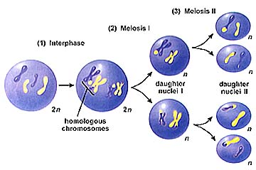
B. Meiosis I
-Prophase I is the first stage of meiosis I and is characterized by the pairing of homologous chromosomes by an unknown mechanism. Synapsis is the process by which homologous chromosomes are linked. The resulting 4-strand structure is known as a tetrad, consisting of two chromatids from each chromosome. Crossing-over occurs at a region known as the chiasma (pl. chiasmata) during prophase I and is one of the sources of genetic variability that arises from sexual reproduction. During crossing-over chromatids break and may be reattached to a different homologous chromosome.

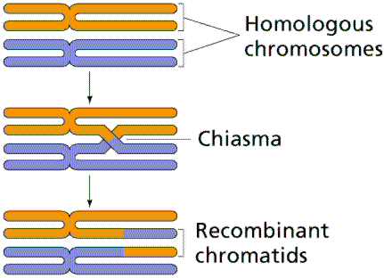
-The events of prophase I (with the exception of synapsis and crossing-over) are similar to the mitotic prophase: the chromatin (replicated chromosomes) condenses, the nuclear envelope disintegrates, the nucleoli disappear, centrioles divide and begin to migrate to opposite poles of the cell, kinetochores and kinetochore fibers form, and the spindle apparatus forms.

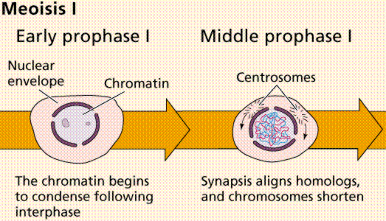

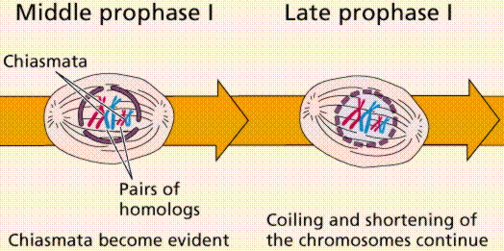

-During metaphase I of meiosis the tetrads line-up along the equator of the spindle (metaphase plate). Spindle fibers attach to the centromere region of each homologous chromosome pair.

-Anaphase I of meiosis is characterized by separation of the tetrads and subsequent spindle-mediated migration of the chromosomes (now consisting of two chromatids) to opposite poles by the spindle fibers. The centromeres in Anaphase I remain intact.
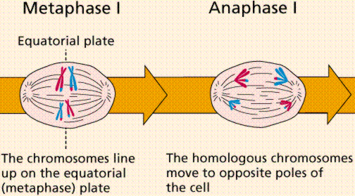

-Telophase I is similar to telophase of mitosis, with the notable exception that only one set of (replicated) chromosomes is in each "cell". Depending on the species, new nuclear envelopes may or may not form. Some animal cells may have division of the centrioles during this phase.

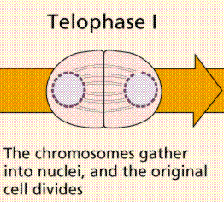
C. Meiosis II

-Meiosis II is characterized by a prophase, metaphase, anaphase, and telophase, but no additional DNA synthesis occurs between meiosis I and II. Meiosis II is almost identical to mitosis, a notable exception being the production of haploid daughter cells with genetic variability rather than the identical daughter cells produced in mitosis.

-Prophase II of meiosis involves the disintegration of the nuclear envelopes (if they reformed in telophase I), and the formation of the spindle apparatus. Prophase II of meiosis is analogous to the mitotic prophase.

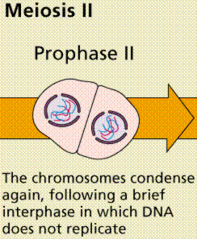

-Metaphase II in meiosis is again similar to metaphase in mitosis. The spindle apparati move the chromosomes into the spindle equator (the metaphase plate) and attach to the centromeres in the kinetochore region.

-During Anaphase II, the centromeres split and the former chromatids (now known as chromosomes) are segregated into opposite sides of the cell.

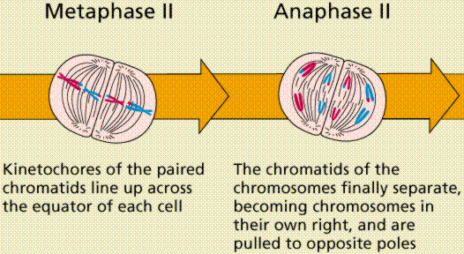

-Telophase II of meiosis is identical to telophase of mitosis and is followed by cytokinesis.

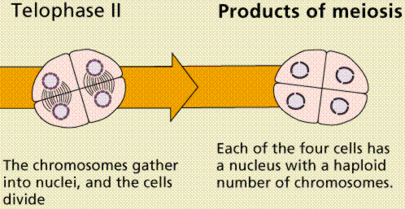

IV. A Brief Comparison of Mitosis and Meiosis

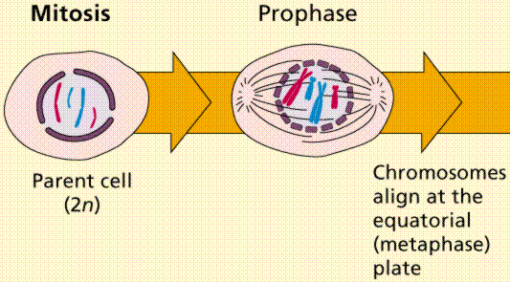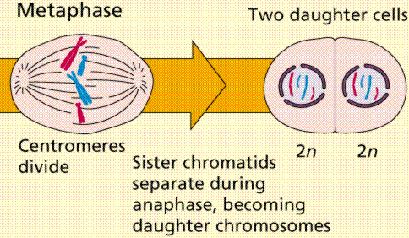

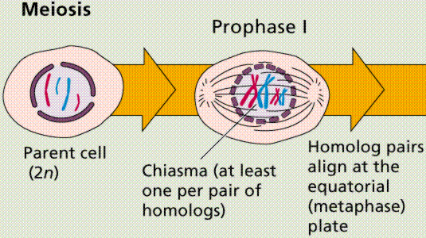
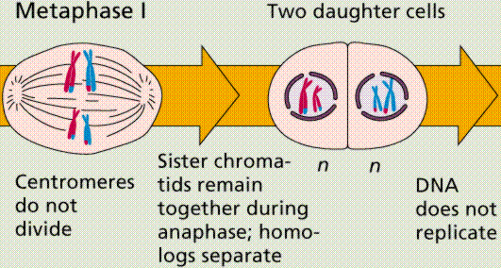
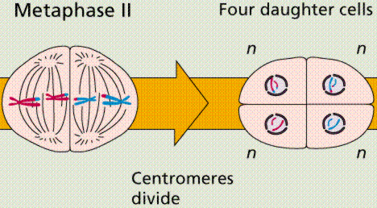

V. Gametogenesis

- The Basics

-Gametogenesis is the process of forming haploid gametes from diploid germ cells. Spermatogenesis results in the formation of sperm cells, while oogenesis is the process of ovum (egg) generation; both processes occur by meiosis. In spermatogenesis, all 4 meiotic cells develop into gametes, only 1 cell in oogenesis becomes a gamete, the remainder become polar bodies.

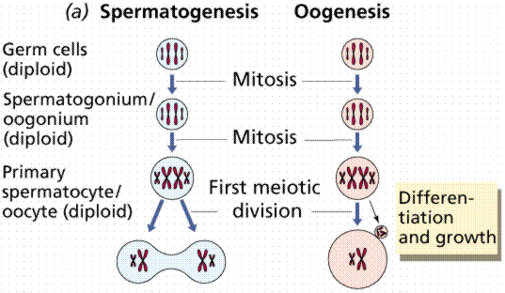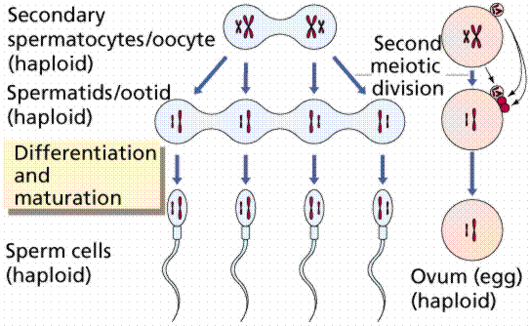
B. Spermatogenesis
- Sperm production begins at puberty at continues throughout life, with several hundred million sperm being produced each day. Once sperm form they move into the epididymis, where they mature and are stored.

- Spermatogonia: Early in development (6 weeks in human) primordial germ cells invade the genital ridge where the epithelial sex cords (to become the seminiferous tubules) are forming the testis. Spermatogenesis begins when primordial cells of the embryonic tissue differentiate into spermatogonia, the diploid precursors of sperm. Spermatogonia are located near the outer wall of the seminiferous tubules and undergo numerous cycles of division to produce potential sperm.

- The production of sperm cells from spermatogonia (2n) occurs via primary spermatocytes, produced by mitosis of spermatogonia. These primary spermatocytes (2n, tetrads) undergo subsequent meiotic division (Meiosis I) to produce secondary spermatocytes (also 2n, but not tetrads). Secondary spermatocytes undergo Meiosis II to become spermatids (haploid, n), which then differentiate into spermatozoa, or mature sperm cells.
- Maturation of spermatids, which occurs only after puberty, involves the association of the developing sperm with Sertoli cells, resulting in the transfer of nutrients and essential factors to the spermatids. Sperm maturation involves a complete cellular remodeling consisting of the following changes:
- The nucleus elongates; chromatin condenses in the head
- The Golgi apparatus becomes the acrosomal vesicle, a modified lysosome to digest proteins and complex sugars on the side of the nucleus facing the lumen.
- The flagellum grows from the centriole
- Mitochondria cluster around the "middle piece."
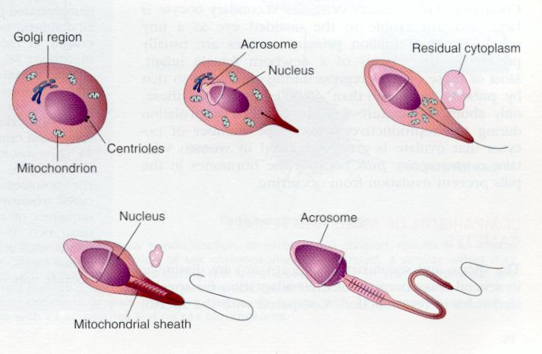

- During spermatogenesis, developing sperm are gradually pushed toward the center of the seminiferous tubule and subsequently toward the epididymis, where they acquire motility.

- Spermatogenesis takes approximately 72 days in the human male.

C. Oogenesis
- Oogenesis occurs in the ovarian follicles. The ovary contains many follicles composed of a developing egg surrounded by an outer layer of follicle cells. Each egg begins oogenesis as a primary oocyte. At birth, each female carries a lifetime supply of developing oocytes, each of which is in Prophase I. A developing egg (secondary oocyte) is released each month from puberty until menopause, a total of 400-500 eggs.
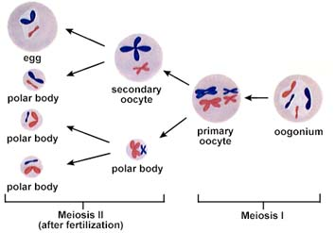
- Oogenesis begins with mitosis of the primordial germ cells in the embryo to produce diploid (2n) oogonia, which develop into primary oocytes (2n, with tetrads). The primary oocyte undergoes meiosis I and unequal cytokinesis to form a secondary oocyte (2n) and a polar body (2n). Upon fertilization, both the secondary oocyte and the polar body undergo meiosis II. Unequal cytokinesis in meiosis II of the secondary oocyte results in the formation of a haploid (n) ovum and a polar body. Meiosis II of the diploid polar body produces two haploid polar bodies, for a total of three polar bodies and one ovum from meiosis II. These polar bodies subsequently degenerate.
VI. Genetic Diseases:

- There are a wide-variety of causes for genetic diseases – most involve aberrations in the transfer of genetic information, as a result of DNA damage or mitotic dysfunction. Chromosomal abnormalities are known as aneuploidies.

1. DNA Damage

-There are four main types of DNA damage that can occur in meiosis:
-Deletion – removal of a chromosomal segment (as seen in 22q11.2 deletions in Velo-Facial-Cardiac Syndrome)

-Inversion – reversal of a segment within a chromosome This can cause altered gene activity, a loss of crossing-over, or a duplication/deletion if crossing-over does occur.

-Duplication – repetition of a segment within a chromosome; it can be due to unequal crossing over which produces a deletion on one chromosome and a duplication on the other. Often, multiple copies of genes from duplication can mutate without harming the individual because they still have one good copy of the gene. This type of mutation may be a source of variation for species. For example, the gene for human globin has given rise to several different genes that produce similar types of proteins. The different globins produced by these genes have very similar amino acid sequences.

-Translocation (Reciprocal/Non-Reciprocal)
-A translocation moves a segment from one chromosome to a non-homologous chromosome (in contrast to crossing-over, which occurs between homologous chromosomes).
-The most common type of translocation is reciprocal, in which non-homologous chromosomes exchange fragments.
-In nonreciprocal translocations, a chromosome will transfer a segment without receiving a fragment in return.

2. Meiotic/Mitotic Non-Disjunction

-Nondisjunction is the failure of chromosomes (tetrads in meiosis I) to separate properly during cell-division and can occur in either meiosis I or meiosis II, but is more commonly found in meiosis I. The result of nondisjunction will be the formation of cells with either too many chromosomes or too few chromosomes.

-Nondisjunction of non-sex chromosomes has been linked to the following disorders: Down Syndrome (non-disjunction of 21, trisomy 21), Patau Syndrome (non-disjunction of 13 – trisomy 13), and Edwards Syndrome (non-disjunction of 18 – trisomy 18)
-Nondisjunction of sex-chromosomes can also result in genetic abnormalities. Any combination of X and Y (up to XXXXY) produces maleness. Males with more than one X are usually underdeveloped and sterile. XXX and XO women are known, although in most cases they are sterile.

Genotype | Phenotype | Origin of  Non-disjunction | Frequency in Population of live births
XO  XXX  XXY  XYY | Turner Syndrome (Female)  Metafemale (Female)  Klinefelter Syndrome (Male)  Normal Male (Male) | Egg or Sperm Formation  Egg Formation  Egg or Sperm Formation  Sperm Formation | 1/5000  1/1000  1/2000  1/2000

